*LONDON BUILDINGS*

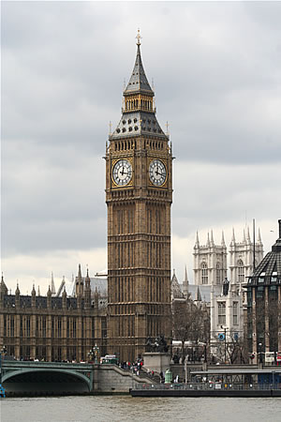  
The Big Ben is the best known building of London. Big Ben is the name given to the great clock bell located on the northwest side of the Palace of Westminster, the seat of the Parliament of the United Kingdom, in London, and popularly by extension is also used to name the clock of the tower. Its official name was Clock Tower until June 26, 2012, in honor of the diamond jubilee of Queen Elizabeth II, it was decided that the tower would be renamed Elizabeth Tower (Torre Isabel) .The tower houses the largest four-sided clock in the world, and is the third tallest clock tower in the world. It celebrated its 150th anniversary on May 31, 2009, and various commemorative events were held. The tower was completed in 1858 and the clock started operating on September 7, 1859.

The tower of Big Ben is a British cultural icon, since it is one of the most prominent symbols of the United Kingdom and frequently appears as a setting plane in films, television series, programs or documentaries set in London.7

**BY : Miriam y Rocio**